**EXPERIMENT 3**

RELATIONAL MODEL FOR COLLEGE DATABASE

**Aim:** Draw a relational model for college database

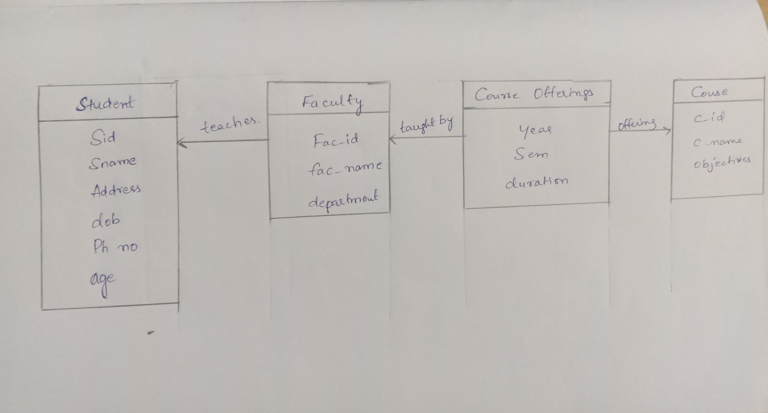

offering

Cid

C_name

objectives

**Course**

Year

Sem

duration

**Course offerings**

taught

by

**Faculty**

Fac_id

Fac_name

department

teaches

**Student**

Sid

Sname

Address

Dob

PhNo

age